# MM 203 Assignment 1

Q1. Two equal cylinders, each weighing 900 N are placed in a box as shown. Neglecting friction between cylinders and box, estimate reactions A, B and C.

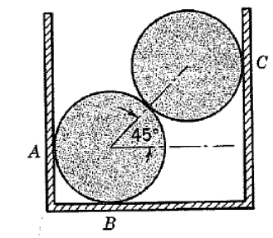

Q2. Find the force and moment which must be applied at O to hold the light bar shown in equilibrium.

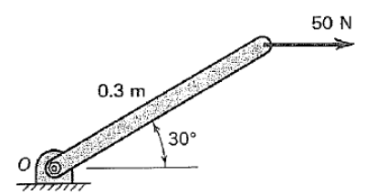

Q3. A downward force of P=800 N is being applied at point C in the given figure. Estimate the force in member AB.

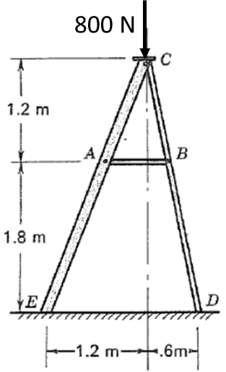

Q4. Find the force carried in each bar of hinged equilateral triangle when loaded as shown.

